

SIMATS ENGINEERING

Saveetha Institute of Medical and Technical Sciences
Chennai- 602105

Student Name: Mohamed Jameel A Reg. No.:192425057
Course Code: DSA0306 Slot: C
Course Name: NATURAL LANGUAGE PROCESSING
Course Faculty: Kumaragurubaran T
Project Title: DocInsight AI: An Intelligent Document Analysis and Question Answering System
Module Photographs: (3 photographs –Module Photo, Individual student contribution module work in the project and presentation image)
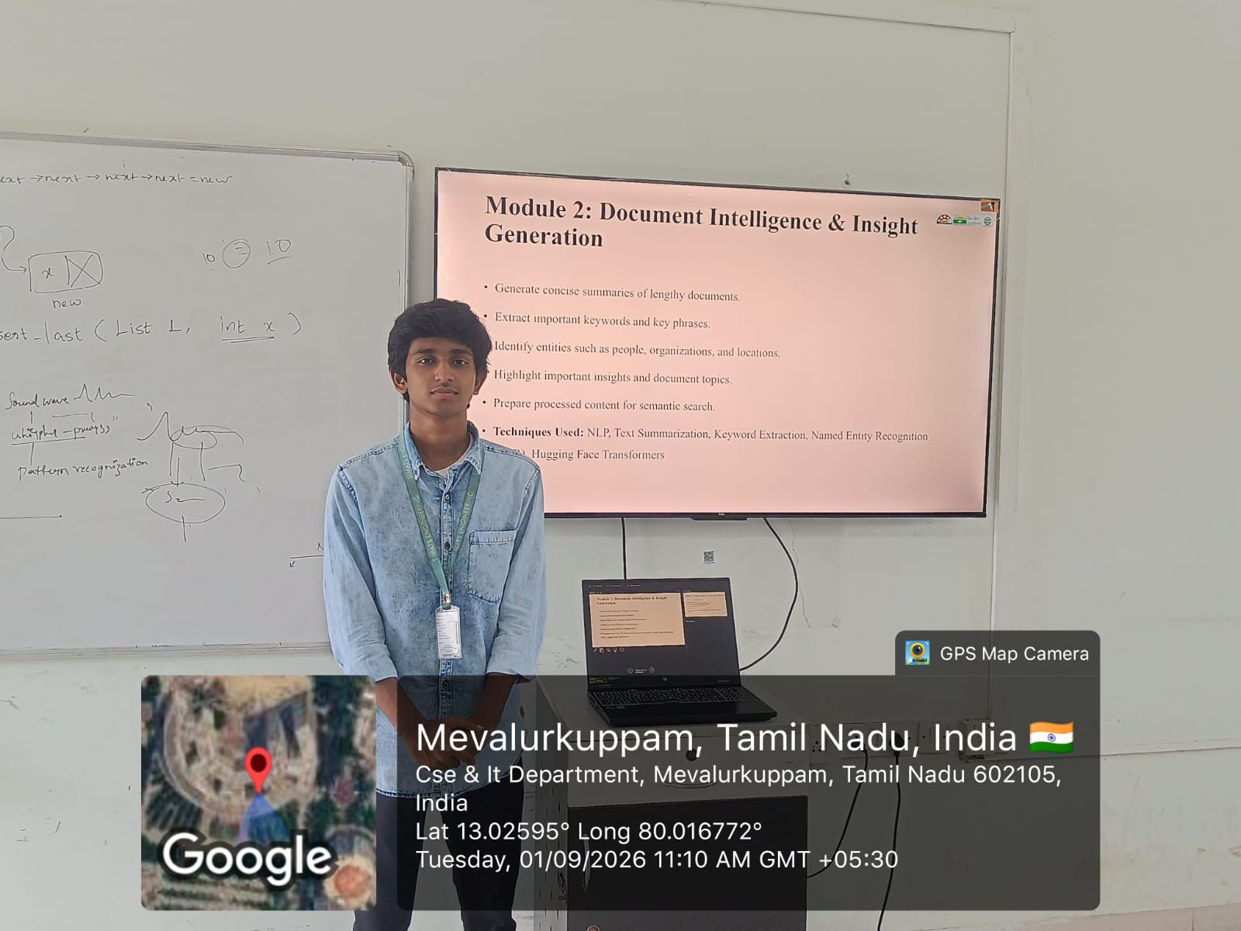
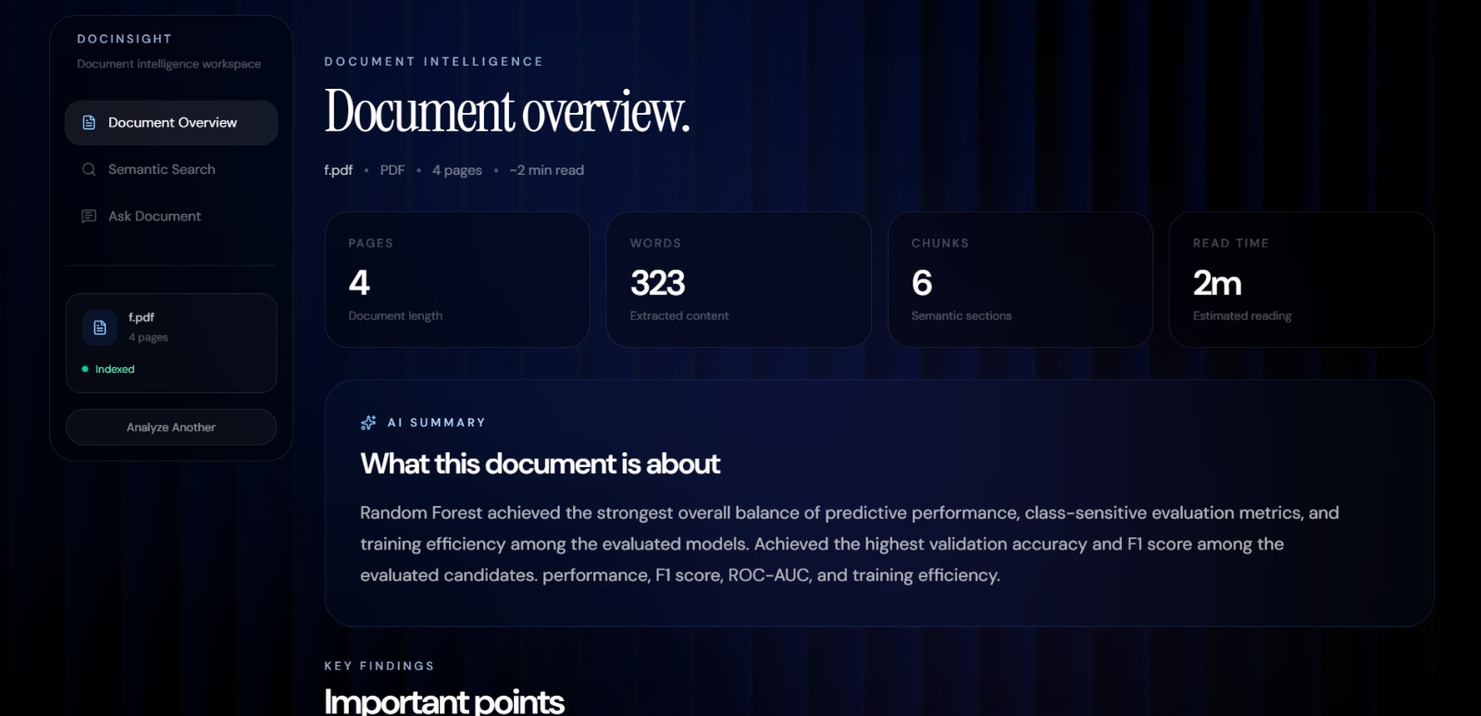
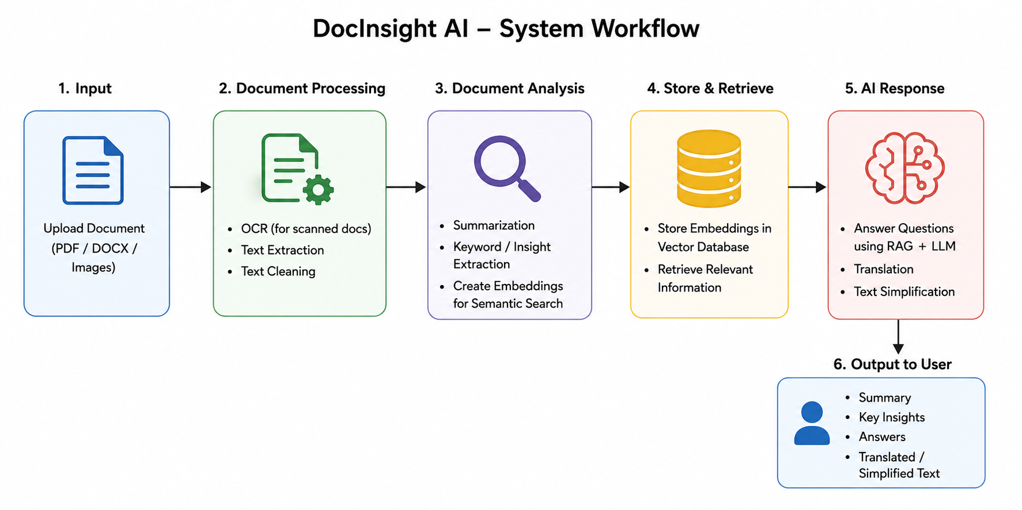
Project Description:

DocInsight AI analyzes uploaded documents to extract important information and generate meaningful insights. The module identifies key concepts, important details, and relevant content from documents using AI and NLP techniques. It helps users quickly understand lengthy documents without reading them completely. The generated insights make document analysis faster, easier, and more efficient. t reduces the time and effort required to manually search through lengthy documents and provides an interactive question-answering interface. The system can be useful for students, researchers, educators, and professionals for quickly accessing information from large documents.
.The system can be useful for students, researchers, educators, and professionals for quickly accessing information from large documents. Overall, DocInsight AI aims to provide an efficient, intelligent, and user-friendly solution for document analysis and knowledge retrieval.

Student Signature Guide Signature

